
Parent School Support Committee
Perth-Andover Middle School – BEARS DEN
Address: 20 Nissen St, Perth-Andover, NB
Minutes
Date: Feb. 4th, 2026
Time: 6:30 pm
Location: PAMS/ BEARS DEN
PSSC Members Present:  Jenna Dyer. Chair  Kathryn Mann  Setira Williams  Hazel Chandler  PSSC Members Regrets:  Jeremie Bosse  Krista Sockabasin (via Teams) | School/DEC Representation Present:  Claudine Dionne, Principal  Jessica Smith (Teacher Rep)  Sofia Rodriguez Gallagher

Meeting called to order at 6:35 pm by Jenna Dyer.
Approval of Agenda - Motion to approve agenda as presented, moved by Kathryn, second by Setira, voted and passed.

Approval for Minutes from Dec.8, 2025 meeting – Motion to approve minutes as presented, moved by Jessica, second by Setira, voted and passed.

Business Arising-
Declaration of Office is to be signed by members each year. (Hazel and Setira – signed, all members have now signed the required form)
Standing Items-
Principal’s Report - Claudine
- Enrollment: 189 (net increase of 2 students)

- Staffing:
  - Behavior intervention mentor remains vacant (3rd position), no successful candidates were found during the last posting, the position will be reposted with a Feb 17th deadline.
  - Mme. Michaud is on a referred leave until August. She is replaced internally by Kim Castonguay who is now teaching the grade 6/7 Immersion classes French language arts and social studies. Chantal Gallant is teaching post intensive French grade 6.
  - Mrs. Oakes returned from maternity leave and is teaching grade 6/7/8 science.
  - Hazel Chandler moved to SVHS and is being replaced by a casual, Jayleigh Jamer until June 2026

- Long term recommendation for Middle school
“The big seven” categories and school data was reviewed by staff. The selected focus for PAMS is improving the Learner to Learner relationships.
The goals is for Learners to develop the skills talents and abilities to cooperate in any setting.
PAMS is working with a learning specialist from EECD, Beth Henderson< on this project.

Next steps - Meet with students to gain perspectives. This will occur the week of Feb. 9th when a sample of 20 students will be interviewed. Questions will focus on what cooperation means, what helps students stay focused when working together, what students and adults can do to help groups work better together.….

Feb-June – staff will align language using scripts, model desired behavior and interactions,
communicate with families in hopes it is reinforced with interactions outside of school.

- School Improvement Plan
  - Goal By June 2026, PAMS will improve behavioral engagement by creating a student-centered learning environment. 100% of teachers will intentionally incorporate the three learning styles in classroom instruction. We will tailor instruction to meet the learning styles of students while incorporating choice, voice, and relevance to content areas.
  - Quantitative indicators of success include
    - Increase of 10% on Engagement scores on Provincial Student Survey (December) and PAMS Survey Scores (December/March/June) on the following questions:

Q12: “What I learn helps me understand the world.”
Q4: “I have choice in my schoolwork.”
Q6: “My teachers listen to my ideas.”

December results
Grade 6 has no baseline data as students did not participate in the survey at PAMS in 2025
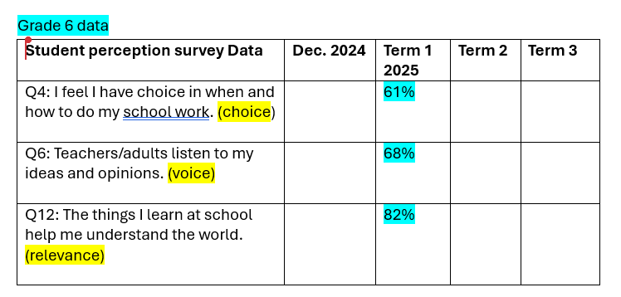

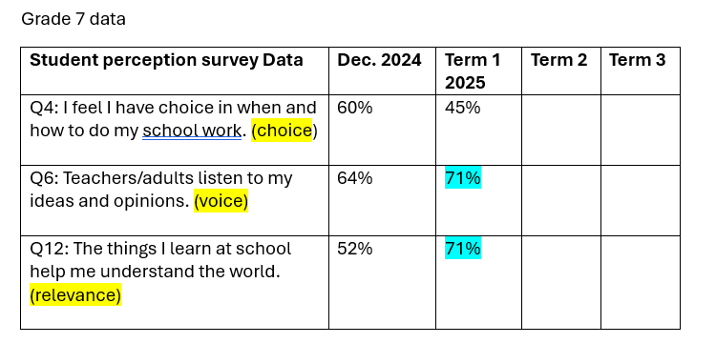
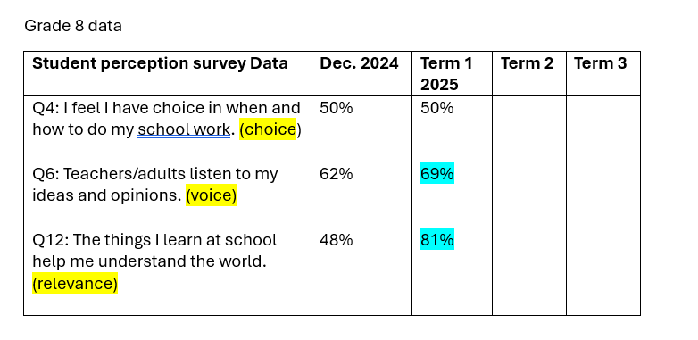
Survey will be repeated in April following the distribution of term 2 report card.
Projects and Events – Jessica Smith
Anti-racism pilot : PAMS was invited to participate in the ASD- West: Anti racism Pilot Project along with Woodstock High, Leo Hayes, Fredericton High, and Devon Middle. The 1st meeting on Jan. 16th, Mrs. Smith represented PAMS at the meeting. The group is creating a flow chart system of how to address racism in schools. Mrs. Smith felt PAMS has already implemented many initiates to create greater awareness of racism as it was a SIP goal in 2024-25.

Upcoming events for students and staff – Valentine’s theme week and teacher appreciation week Feb. 9th, Southern Victoria Winter Freeze fest Chocolate bar BINGO, Feb. 26th, Outdoor rink (behind the school – classes book times), tubes and tubing hill (front of school – opened at noon), Pink Shirt day – Feb 25th, Grade 5 transition afternoon – Feb. 18th, outdoor fun afternoon on Feb. 25th.

Transition activities for Grade 5 students from AES and Mah-Sos
Feb. 18th PBIS Sliding Party/ Fire/ Hot Chocolate
Feb 26 Chocolate bar Bingo
Mar. 12 AES & Mah-Sos visit for welcome activity.
Apr. 8th PAMS staff visit Mah-Sos and AES for Q and A
Apr. 30 Mah-Sos and AES visit PAMS for assembly and lunch
May 12 Gr 5 Students at PAMS for station activities and get to know you time
May 27 Mah-Sos join PAMS grade6
June - Parents open house

DEC Report: Sofia Rodriguez Gallagher
Sofia provided an explanation of her role for new members- District Ed Counselor sub district 1 (7 schools)
3 PSSC sessions a year per school, Fredericton DEC meetings every 2 weeks

Other information items shared included
- Consultation for New ED plan has concluded, the New plan has been reviewed by DEC to be published by March
- Budget for next year includes more cuts
- Superintendent asked to provide worst case scenario options
- 4 million in RED, due to high need for EA support staff, K- toileting support, Autism support, Gr 12’s staying longer.
- St Mary’s academy had their childcare center removed.
- DEC Chair resigned, Vice-Chair is assuming his duties.
- Elections for DEC chair- Nominations by March 20th
Home and School Update: Jenna Dyer
- Three meetings have been held so far.
-Staff Appreciation week activities: Business donations via Sofia, chili, baked goods, product donations for raffles.
-1 fundraiser in the spring to raise monies for next school year start.

New Business:
PSSC budget – Jenna
- PAMS has a PSSC budget of $750/year, this is determined by school population.
- $68 spent from last year April- now, remaining funds must be spent by end of February and goods received by March 31st, 2026
- Ideas- members brainstormed ideas for funds which included:
    - Sleds ($25 each) Costco
    - Promotional Signage (Wraps) Next year
    - Guest Speaker- Next Year (Maddy Cameron) Social Media & Safety. In person or Virtual, Bullying
    - Student Gifts for assemblies (swag- toques, socks, with logo’s, Jibits)
    - Skating Helmets

Motion: Kathryn moved to spend money on purchases of PAMS swag or sleds. Claudine will make the decision based on price, availability, and if the items can be received by March 31st. Second by Setira. Voted and passed.

Breakfast Program: Claudine
- Currently we offer a hot breakfast 3 days a week. Beginning on March 9th, breakfast will be available 5 days a week. We are still looking for morning volunteers. Members of a church group are going to come for 2 of the 5 days.
Correspondence: none
Closing Comments: Minutes & PPT posted on school website under PSSC
Date of next meeting: March 18 - 6:30
Motion to adjourn: so moved by Kathryn

