
Parent School Support Committee
Perth-Andover Middle School – BEARS DEN
Address: 20 Nissen St, Perth-Andover, NB
Minutes
Date: Dec 8, 2025
Time: 6:30 pm
Location: PAMS/ BEARS DEN
PSSC Members Present:  Emily Brown  Jenna Dyer. Chair  Krista Sockabasin (via Teams)  Kathryn Mann  PSSC Members Regrets:  Setira Williams  Jacki Ciesielski  Jeremie Bosse  Samantha Michaud | School/DEC Representation Present:  Claudine Dionne, Principal  Jessica Smith (Teacher Rep)  Sofia Rodriguez Gallagher

- Meeting called to order at 6:38 pm by Jenna Dyer.
Approval of the agenda
Motion to approve Agenda by Kathryn Mann and seconded by Jessica Smith. Voted – passed.
Approval for Minutes from previous meeting - June/November
Motion to approve (Jenna) Second (Kathryn). Edit required as Sophia was present at the meeting (Nov 4TH minutes). Edit was noted. Voted – passed.
Business Arising from the minutes
Declaration of Office is to be signed by members each year. (Jessica, Jenna and Kathryn- signed)

Standing Items-
#1 Principal’s report
- Attendance
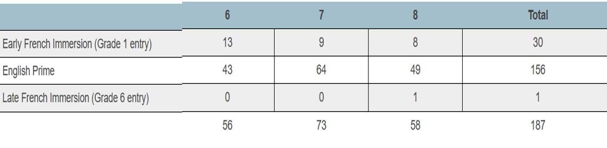

- Staffing update
- Custodian change – Dawn Eccleston
- BIM (behavior intervention mentor) – remains vacant, no suitable applicant
- Kim Michaud – deferred leave begins Jan. 5th
- Kayla Oakes – returns Jan. 26th

- EECD Long term recommendations 2.1 Revitalizing Middle school block
PAMS Focus will be on learner-to-learner relationships - Learners actively listen and show respect to others, trying to understand different perspectives.

Our Strategies will include: Staff will co-construct what respect interactions - looks like / sound like / feels like (Jan. 12th , 2026). Classroom connections time will focus on respectful interactions through group activities (Feb – June 2026)

The school improvement connections – positive learner to learner relationships is a prerequisite to the implementation of engaging learning strategies.

- EECD Long term recommendation 3.1: Encouraging Movement –
PAMS has been accepted in this LTR with a focus on Physical Activity and Wellness. Our project is to construct a trail in the wooded area behind the school. The PAMS Champion for this project is Chantal Gallant

- Youth Check in Results:
164 students from PAMS participated in the survey (November 2025). The results showed the following:
Mental health : 71% of students report good to excellent mental health, 20% seek emotional support frequently (more than 4 times)

School Relevance: 85% of students find their learning skills useful, 74% feel cultural pride from school teachings.

School Relatedness: 79% have supportive adults at school, yet only 66% feel part of the community and 62% feel peer support.

PAMS Staff meeting tomorrow will review this data as a group and offer feedback on how we can take the data and make suggestions for actions to aid in improving this coming year.

#2 SIP Update-
GOAL: By June 2026, Perth Andover Middle School will improve behavioral engagement by creating a student-centered learning environment. 100% of teachers will intentionally incorporate the three learning styles in classroom instruction.
PAMS staff had 1.5 Professional learning days devoted to the plan. Nov 10th/ Dec 5;
Nov. 10th - activities included Learning Style Inventory PL for teachers, time to reflect on student learning styles of our students and planning time to intentionally incorporate new strategies to meet the learning style of their students in lesson plans.
Dec 5th. Half day where Support staff and Teachers focused on a particular subject area to plan activities that meet the three learning styles to engage all students in learning.

#3 Home & School –
Next meeting is scheduled for January 15th. We hope to have more attend to allow for voting, last meeting was not well attended.

#4 DEC Report: (Sofia Rodriquez Gallagher)
Policies Review- DEC chair shared that committee is concerned about new school plans approved in past and now reviewing in December it appears things have changed for example: (Edmundston; day care/ School being built for less student than the demands- starting off with overcrowding) Bath school not on docket, etc.
New Budget- PAMS did not get selected for parking lot improvement. Overall, it was shared that there are concerns from the DEC committee for what was chosen for budget items and two councilors looking into appeal process.
ADM- Education plan visited DEC meeting to gain feedback on plan. DEC members suggested reviewing 2010 targets when things were going well. What programs were cut?
Spring Draft Education Plan date to be determined
Next DEC meeting will be held on Thursday (Dec 11)

#5 Upcoming Events
Family Night Bingo- Dec 11th
Christmas dinner- Dec 11th
Christmas breakfast- Dec 17th
Poinsettia’s /Honey fundraisers – completed but honey is still available from PAMS $12/bottle
Academic Assembly- Dec 12th

#6 New Business
Principal List- Dec 2025: Bronze- (7) Silver (15 students) Gold (1)
The principal’s list assembly and outing is being planned for next week – watch for an email.

Claudine asked to (Defer Budget to next Meeting)- approved

#7 Correspondence: none

Closing Comments: Minutes & PPT posted on school website under PSSC
Date of next meeting: (Jan 26- 6:30)
Motion adjourned- Kathryn Mann ( End: 7:40 pm)

