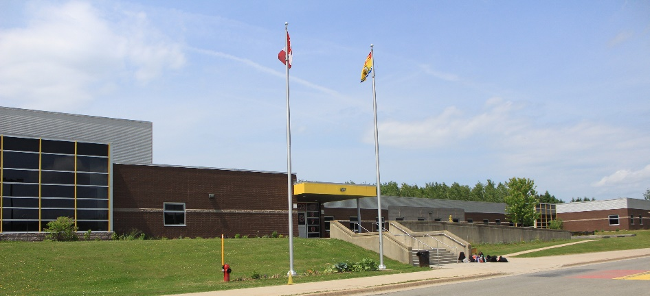


Parent /Student Handbook
2026-27

Student: _________________________________
Homeroom: _____________________________

20 Nissen Street. Perth-Andover, NB E7H 3G1
(506) 273-4760
https://pams.nbed.ca/
perth-andovermiddle@nbed.nb.ca

Perth-Andover Middle School h

Welcome to PAMS
We are excited to welcome you to another fantastic school year at PAMS! This handbook outlines our shared expectations and provides key information to help maintain a positive, respectful learning environment. It reflects the responsibilities we all share in upholding our school’s mission, vision, and values.

At PAMS, we embrace diversity and foster an inclusive space where every student feels valued and supported—regardless of gender identity, sexual orientation, race, or religious beliefs. Our school community is built on positivity, respect, accountability, and belonging for all.

As a PBIS (Positive Behavioral Interventions and Supports) school, we focus on teaching and reinforcing positive behavior. PBIS helps us create a consistent and supportive environment where expectations are clear, and everyone can succeed.
We look forward to a great year of learning, growth, and success together!

Mrs. Claudine Bouvrette-Grant - Principal
Mrs. Katrina Paget – Vice Principal

A message from our Superintendent
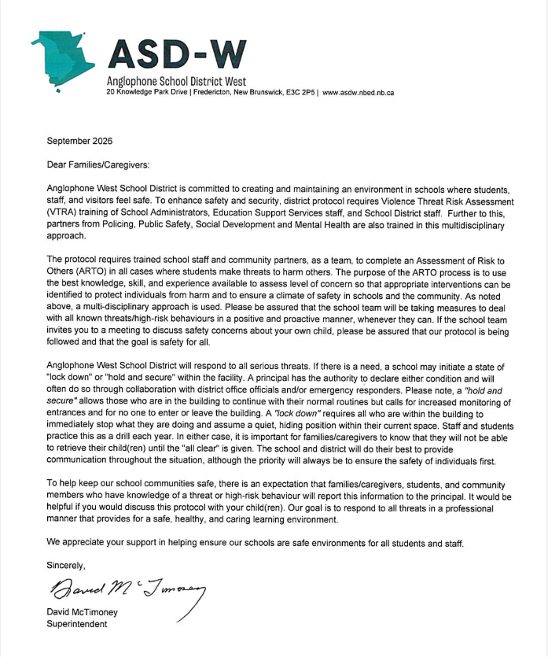

PAMS Teaching Staff
2026-2027

Administration
Claudine Grant claudine.grant@nbed.nb.ca
Katrina Paget katrina.paget@nbed.nb.ca

Resource teacher
Kari Harper-Merrithew
kari.harper-merrithew@nbed.nb.ca

School counsellor
Jessica Smith jessica.smith2@nbed.nb.ca

Classroom teachers
Gus Briggs gus.briggs@nbed.nb.ca
Kim Cheeseman kim.cheeseman@nbed.nb.ca
Heather Crain heather.crain@nbed.nb.ca
Erin-Beth Daneluk erin-beth.daneluk@nbed.nb.ca
Kalib DeMerchant kalib.demerchant@nbed.nb.ca
Chantal Gallant chantal.gallant3@nbed.nb.ca
Michael Grant michael.grant@nbed.nb.ca
Kim Michaud kim.michaud@nbed.nb.ca
Nathalie Morin nathalie.morin@nbed.nb.ca
Kayla Oakes kayla.oakes@nbed.nb.ca
Tara Leslie-Perley tara.leslie-perley@nbed.nb.ca
Meenu Yadav meenu.yadav@nbed.nb.ca

Our Mission

Positivity Belonging Resiliency

Our Vision

At PAMS, we create a positive learning environment that promotes a sense of belonging and resiliency for ALL.

BEARS CODE

Belonging
- Include others
- Encourage and be supportive

Empathy
- Acknowledge we are all different
- Be kind

Achievement
- Practice a growth mindset
- Plan for success
- Complete tasks

Respect
- Practice good manners
- Use school appropriate words
- Take care of school and personal property
Safety
- Stay in your assigned space
- Keep hands, feet, and objects to yourself
- Follow instructions
PBIS
Our school is guided by seven key expectations that help create a caring, respectful, and productive learning environment for everyone. These expectations shape student behaviour throughout the day and support our PBIS (Positive Behavioural Interventions and Supports) culture. We appreciate your partnership in helping your child understand and follow these important guidelines.

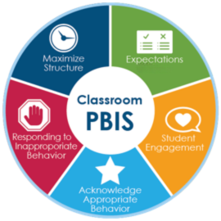

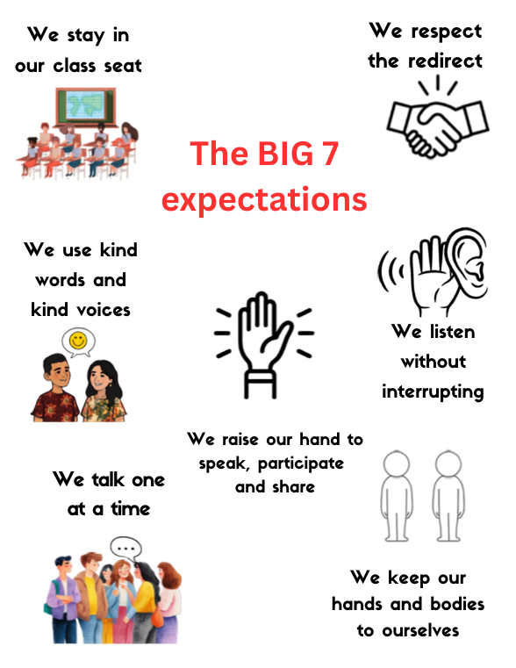

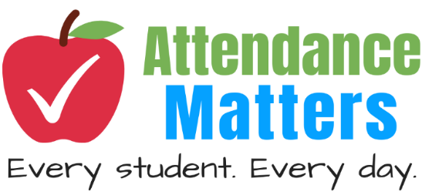
Regular attendance is a vital factor in being successful at PAMS. To maximize and respect teaching-learning time, every minute of the school day is valued. Students are expected to arrive on time each morning and stay until dismissal so they can fully benefit from classroom learning and routines. The Education Act recognizes that regular attendance supports the learning success of the student and contributes to the learning environment of the school. Education Act – article 13-1.

Absence from class for any reason does not excuse the student from their responsibility of completing assignments and learning the material covered during their absence. It is a student’s responsibility to connect with their teacher when they return from an absence.

Parents, please contact the school anytime your child will be absent (273-4760) or email (perth-andovermiddle@nbed.nb.ca). An automated call goes out to the homes of all students with unexplained absences in the morning. If a student is absent, extra-curricular privileges are cancelled (games, spectators, practices, dances…) Students expecting to participate in after-school events and practices must stay all day.

School opens/ Breakfast 8:20 – 8:40am
Classes begin 8:40am
Lunch 12:15- 1:00pm
Classes ends 2:50pm
Dismissal bell 3:00pm
ARRIVALS AND DEPARTURES
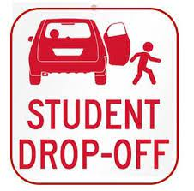
Morning drop-off procedure
We encourage all families to send their children on their assigned school bus.

Any family who chooses to drive his or her child(ren) will drop students off from the parking lot. Vehicles should stop in front of the crosswalk. Please do not drop your child off or stop in the bus lane anytime during the day. All drivers must respect the 10km/hr speed zone throughout our driveway.

All doors are locked after the final bus arrives. All students arriving after this time must to buzz to have access through the main door. Students will sign in at the office, order their lunch at the cafeteria, and proceed to their homeroom class.

When a student needs to be picked up early from school the parent or guardian should notify the office. Parents/guardians must come in the school to pick up their child. The school requires verbal or written consent for any person other than the parent/guardian to pick up a child from school.

Departure procedure
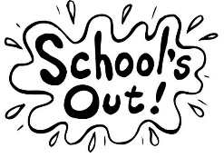
Bus students are dismissed once all buses arrive at the end of the day. To ensure a safe departure, walkers and students being picked up leave the building only after the buses depart.
Parents picking up students should follow behind the final bus. The parent pick-up lane is in the front of the school, the lane closest to the sidewalk. The parking lot will not be used to pick up students.

STUDENT FEES
The student fee of $45 covers the student lock rental, school-wide performances, art and technology supplies, this handbook, and some grade level activity fees.

Fees may be paid online at https://www.schoolcashonline.com/ or at PAMS by cheque or cash. Fees must be paid by October 30th. Families who need support with school supplies should contact the school at 506-273-4760.

STUDENT HEALTH AND WELLNESS


Health Services
Public Health provides immunizations to grade 7 students on November 16th, 2026, for the HPV (Human Papillomavirus), Tetanus, Diphtheria, and Pertussis. Students and parents will receive a link to information and online consent forms at the beginning of the school year by email. If you have any questions, please contact the Public Health Immunization line @ 506-325-4773 or by email at UVImmunization@gnb.ca.


Medication
Administration of medication to students is the responsibility of the students’ parent/guardian. If it is necessary for school staff to administer medication at school, written permission must be given by parents, and a medical form (EECD Policy 704) must be completed. This includes both prescription and over the counter medication.
Instructions cannot be given by telephone or email.
www2.gnb.ca/content/dam/gnb/Departments/ed/pdf/K12/policies-politiques/e/704A.pdf

Allergy Aware – Peanut free school


PAMS is an allergy aware school. We have several students and staff in our school who have allergies. Ingesting even a tiny amount of these items could be serious or even life threatening. Although it is not possible to guarantee freedom from allergen contamination, staff make every effort to exhibit due care and responsibility in providing the safest environment possible for students. Please do not send any food with peanuts to school.

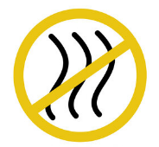
Scent sensitive
At PAMS, we expect students to avoid using strong scents (perfumes, hand sanitizers, hair, and body products) in the building. This will minimize allergic reactions for students, staff, and volunteers with respiratory allergies or asthma. Due to our commitment to provide a safe learning environment for all, these expectations are strictly enforced.
704AE-1.pdf


The Kids Help Phone is an excellent resource for students experiencing difficulties, questions, or concerns. This free phone line is accessible 24 hours. Kids Help Phone @ 1-800-668-6868.


PSST world stands for - Protecting Safer Schools Together is an online reporting tool to help create a safer environment where students can learn and work. If you have a concern that you want the school to know about, go to https://www.PSSTworld.com. and share. It is anonymous and monitored during the school day.


VOLUNTEERS
Parent/guardians, we want you to be an active part of our school community! We invite you to join the PAMS community as a volunteer. If you would like to support our breakfast program or share a hobby, talent, or special interest with our students, please contact the school at 273-4760.

LOCKERS AND LOCKS
Students are expected to store their bookbag, books, coats, lunches, cell phones, and other valuables in their lockers. Students may choose to use a lock on their locker if they wish.

Those who would like a lock can obtain one from their homeroom teacher and are expected to use it properly. Students who choose not to use a lock are responsible for any lost or stolen belongings. School is not responsible for any lost or damaged belongings. Only school-issued locks are permitted on lockers.

SMOKING AND VAPING
Smoking/Vaping is always prohibited for adults and students at PAMS. This includes all school grounds (buildings, parking lot, in vehicles, sports field, fire pit, spectator area). Extensive education on the dangers of smoking is provided to all students throughout the year.

Students are not permitted to bring lighters, matches, tobacco, vape, drugs, alcohol, or nicotine liquid to school (EECD policy 702 – Tobacco Free schools/Policy 703 – Positive Learning and Working Environment).


CELL PHONES AND ELECTRONIC/GAMING DEVICES
The safest place for phones and electronics is home. If your child chooses to bring them, they are stored in student lockers throughout the school day including recess and noon hour. Students can use their phone once they have left the building at the end of the day. If a device is seen during the day, students will be asked to return it to their locker, or it will be stored in the office. Parents/guardians should call the main office (273-4760) if they need to connect with their child during the day.

THE BEARS DEN
Our library (BEARS Den) has a wonderful selection of books that our students can read in class or at home. If there is a book that you would like, please let Mrs. Grant know. The BEARS Den also hosts various gatherings and social events.

BIKE/SKATEBOARDS AT SCHOOL
Students who bike/board to school must:

- Wear a helmet.
- Lock their bikes up to the bike rack provide and bring boards to the PE office.
- Use safe driving/riding practices.
- Leave with walking students at the end of the day.


Bikes and skateboards should only be used by their owner to travel to and from school, not during recess or lunch. PAMS is not responsible for lost, stolen, or damaged items. Student may not bring a motorized vehicle to school (scooter/4-wheeler/side by side).

Students Leaving School Property
PAMS is a closed campus. If a student is leaving early or at lunch, the parent or guardian must come inside the building and sign out the student. Only the adults listed on the contact list may sign out or pick up a student.
For emergency changes to afterschool plans, parents/guardians must call the school. Parents can choose to sign the consent sheet sent home at the beginning of the year to give their child permission to walk off grounds afterschool instead of going on the bus. Without consent, all bus students must take the bus at the end of the day. Permission is important to ensure the safety of all students.

DRESS FOR SUCCESS AND OUTDOORS

Students should dress for comfort in their learning environment. They should also wear appropriate clothes for outdoor recess each morning and lunch. Slogans/ graphics should be positive and appropriate for school; they should not be questionable or offensive. Alcohol or drug symbols are not acceptable at school.

COMMUNICATION

PAMS staff is eager to get to know families and answer your questions. If you wish to speak to a teacher or an administrator, please make an appointment by calling or emailing the school. It is important to respect classroom and teaching time during the hours of 8-3:00 pm.

EARLY DEPARTURE
In the event of an early school closure, parents/guardians will be notified that buses will depart early through email, voicemail, and social media.
Weekly homeroom updates – Homeroom teachers communicate by email at the beginning of each week to share the students “week at a glance”. This includes a brief outline of what students will be learning in each subject. Should your contact information change throughout the year, please inform the main office so you continue to receive these important emails.

School wide events and reminders
Mrs. Grant sends general information to parents regularly by voicemail and email. Our newsletter highlights important events happening during the month. It is sent home with students, emailed to parents, and posted on Facebook.

Social Media and the PAMS website are used regularly to share PAMS information. PAMS Facebook messenger is not used to communicate with parents.

Parents email and calls are returned during regular work hours, 8:00 am – 4:00 pm. Staff will return calls/emails within two workdays, teachers cannot return calls while students are at school and teachers are teaching or supervising classes.

REPORT CARDS

Report cards are sent home three times a year -December 7, April 5, June 25. Progress reports are sent home in February.
Report card marks are based on a variety of evidence collected over time, including classwork, assessments, projects, teacher observations, and conversations with students.
PHOTOS AT SCHOOL & SCHOOL EVENTS

Student photographs will be taken at PAMS on October 27th. These are for yearbooks, class composites, and cumulative records. Photographs may be purchased from the photographer online or through the school.

With parent consent, photographs taken throughout the year to spotlight special events and classroom learning may be posted on social media and in the yearbook. Consent forms are sent home in September.

All photos taken by students or parents at schoSol events (sporting events, special activities, after school events) are not to be shared (text, email, social media) without the consent of the parent of each child in the photo. It is the responsibility of the person taking the photo to get consent.

BUS POLICY
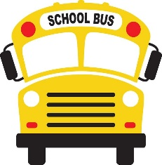
Students are expected to take their assigned bus daily. Parents must complete a form to receive an alternative stop for their child. The alternate bus/stop must follow a regular schedule (every Friday, last Tuesday of the month, etc.).

Basic Bus Safety Expectations
- Respect the driver and others
- Remain seated
- Keep aisle clear
- Talk quietly
Bus passes will not be given to friend's home. Riding the bus is a chance to show safe, respectful, and responsible behavior. Following bus expectations ensures a positive experience for all. Repeated unsafe behavior may lead to losing bus privileges. (EECD pupil transportation of students - Policy 514).

NUTRITION
PAMS provides a breakfast program each morning in the cafeteria from 8:20 to 8:40am. Yogurt, cereal bars, cereal, cheese, milk, and fruit snacks are provided each day. Hot breakfast items are prepared by volunteers. Please consider volunteering to ensure the success of this important program.


NB School Lunch Program
Our school will be participating in the new School Lunch Program, with meals provided by Chartwells each school day. Families can order a healthy daily meal, including a vegetarian option, for $4 per meal, with the province covering the remaining cost. Please refer to the information sent to families (week of August 31) with directions on how to register, sign up, and place meal orders before the start of the school year.

This year, all students will be eating/going outside between 12:15 to 1:00pm each day. All students will eat in the cafeteria on two rotations 12:15 – 12:35 or 12:35 – 1:00pm.

EXTRA-CURRICULAR ACTIVITIES
Students are encouraged to take part in the extra-curricular activities at PAMS. These activities enhance school spirit, improve self-esteem, and develop fond memories. Listen to our daily announcements and visit our school website for a list of activities that are taking place at PAMS.

When activities are off school property all ASD-W and school regulations and policies remain in effect. Our students are expected to follow our BEARS code.

Remember, students must attend school to participate or be a spectator at a PAMS sporting event after school hours at PAMS. Students may only wait afterschool for an event if it begins immediately after dismissal. Otherwise, students are expected to go home and return for the event. The supervision of students at these events is the responsibility of the parent or guardian. Students who are not following school expectations, will be removed and reminded of the BEARS Code expectations. If the behavior continues, they will be asked to leave the event.

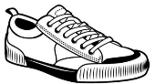
GYM Policy
Students must have indoor gym sneakers for gym class. Students who do not have appropriate indoor footwear will be unable to participate in physical education activities. It is unsafe and not permitted to wear crocs, boots, bare or sock feet in gym class.

Students and adults attending special events are required to bring indoor footwear or remove outdoor footwear at the gym door.


WOODSHOP AND CULINARY TECHNOLOGY SAFETY
To ensure a safe and productive learning environment, students participating in Woodshop and Culinary Technology classes are required to follow all safety expectations. Proper attire is essential for participation in hands-on activities. Students must wear closed-toe shoes, long pants, and have long hair securely always tied back.
These precautions help reduce the risk of injury when working with tools, equipment, and food preparation materials. Students who do not meet safety requirements may not be permitted to participate in certain activities.



SPECIAL EVENTS (dances, sliding party, movie nights)
After-school special events are an exciting opportunity for students to connect and celebrate. Event times may vary, and students are expected to stay for the entire duration. Parents are encouraged to arrive promptly at the designated pick-up time. To attend, students must meet attendance requirements, such as being present in class and having no more than two unexcused absences in the previous four weeks.

